Imagine that you are reading blog postings from an exchange student who is in Russia.
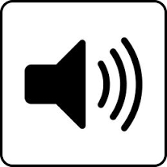
Утром мы с Дашей решили поехать гулять по Москве. Мой учитель русского языка много рассказывал нам о Красной площади. Учитель говорил, что если вы первый раз в главном городе России, то свое знакомство со столицей надо начать с ее сердца - Красной площади”. Поэтому мы сначала стали смотреть по карте в телефоне как добраться туда. Лучше всего было ехать на метро. Красная площадь находится в самом центре города, и рядом с ней несколько станций метро: «Охотный ряд», «Площадь революции» и «Театральная».

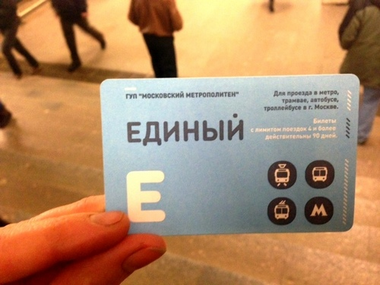
Недалеко от дома, где живет Даша есть станция метро "Красные ворота". До нее мы дошли пешком. Чтобы ехать на метро, мы купили в кассе на станции карточку с оплатой нескольких поездок.

От станции “Красные ворота” нам нужно было доехать всего три остановки до станции "Охотный ряд". Поезда здесь ходят очень быстро, почти каждые 90 секунд, а людей очень много, особенно в час пик.

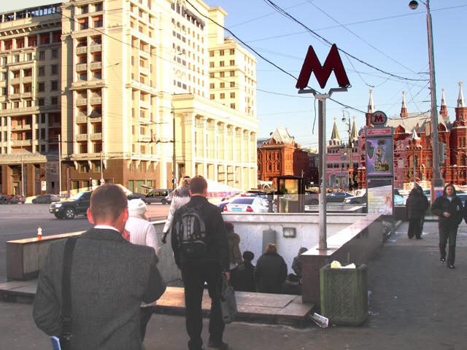
И вот мы наконец находимся в сердце Москвы. Именно здесь проходили исторические парады, демонстрации и другие важные события в истории Российского государства. Как здорово было увидеть Красную площадь своими глазами!

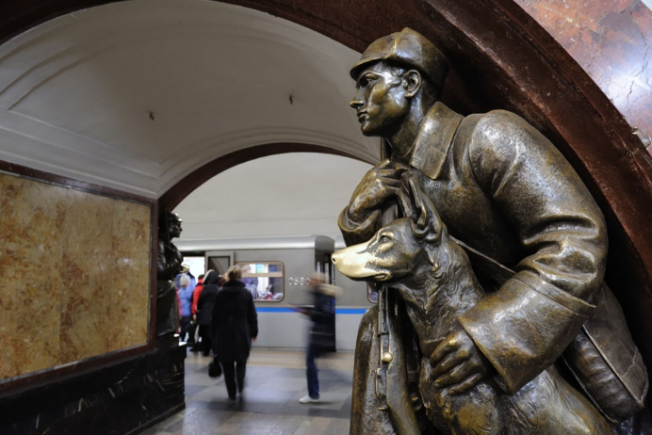
Обратно домой мы поехали через станцию метро “Площадь Революции”. Есть такая примета, если студент прикоснётся к носу собаки пограничника, то успешно сдаст экзамены. А мне это очень нужно в новой школе! “Ну вот, начинаются русские предрассудки” - улыбнулась Даша.

Comprehension Checks

Упражнение 1

Directions: Make a list of Russian words and phrases that come to mind when you hear the words “экскурсия по Москве.” Include as many words and phrases as possible, using no more than two minutes to write your list.
For example: гулять по Москве

Упражнение 2
Directions: Exchange your list of words and phrases about “экскурсия по Москве” with a partner. Create as many questions as you can, based on your partner’s list. Try to create at least 4 questions. Then take turns asking and answering questions. Ask yes/no questions or use question words such as “Кто? Когда? Что? Где? Куда? Как?”
Examples:
Ученик из Америки и Даша ехали на метро?
Где находится Красная Площадь?

Упражнение 3

Directions: Based on the account of the excursion to Red Square, put the following statements in order according to what the student and Dasha did first, second, etc. Write the number for each next to the statement.

№ | Sentence
 | Они дошли пешком до станции метро «Красные Ворота».
 | Они увидели Красную Площадь.
 | Они поехали домой со станции «Площадь Революции».
 | Они решили поехать гулять.
 | Они посмотрели по карте в телефоне.
 | Они доехали до станции «Охотный Ряд».
 | Они купили карточку с оплатой нескольких поездок.

Упражнение 4

Directions: Write a brief blog entry about what you want to do when you are in Moscow. You may want to use some of the following phrases:
Я хочу увидеть....
Когда я буду в Москве....
Я хочу поехать ....
Я хочу купить....
Я хочу посмотреть....

STUDENT PROGRAM LEARNING PLAN
Module 2 Learning Plan #4

Date: |  | Grade Range of Learners: |  | Pre-college students | Targeted Performance Level: | IM
Time Allotted for This Learning Plan: |  |  | 90 min

Lesson Can-Do Statements
Identify specific Lesson Can-Do statement(s) from the Program Can-Do statements in the Curriculum Template (column 2) that are appropriate for and specific to this learning plan.
I can ask and answer questions about an excursion. (IS)
I can identify some information about an excursion. (IR)
I can write about what I want to do in Moscow. (PW)

Indicate what learners need to know and understand to meet the Lesson Can-Do statements above.

Culture |  |  | Content |  |  | Language
Moscow Subway and its importance  Public transportation  Russian traditions |  | How to use the subway in Moscow  Touching the monument for good luck |  |  | Добраться на метро, проезд, карточка, оплата,  русские предрассудки, по примете,

EPISODE # 1 |  | Number of minutes  for this episode: 30
STAGE 1  Lesson Can-Do Statement(s) Addressed: See box above | STAGE 2  Check for Learning  Task or activity learners will do to provide evidence that they are making progress toward the Lesson Can-Do statement(s).
I can identify some information about an excursion.(IR) | Learners will read the blog and make a list of words based on text comprehension.
STAGE 3
Enabling Activities
Tasks that lead learners to demonstrate what they can do with what they know.
Make list of Russian words and phrases that come to mind when you hear the words “экскурсия по Москве.” Include as many words and phrases as possible, using no more than two minutes to write your list.
Differentiation Strategies
Adjustments to instruction or activities to meet learner needs based on age, readiness, process, or output.

EPISODE # 2 |  | Number of minutes  for this episode: 20
STAGE 1  Lesson Can-Do Statement(s) Addressed: See box above | STAGE 2  Check for Learning  Task or activity learners will do to provide evidence that they are making progress toward the Lesson Can-Do statement(s).
I can ask and answer questions about an excursion. (IS) | Learners will exchange their findings from their “экскурсия по Москве” list by asking and answering questions about the text.
STAGE 3
Enabling Activities
Tasks that lead learners to demonstrate what they can do with what they know.
Learners will exchange their list of words and phrases about “экскурсия по Москве” with a partner. Together they will create as many questions as they can, based on the partner’s list. Learners will create at least 4 questions. Then take turns asking and answering questions. They will ask yes/no questions or use question words such as “Кто? Когда? Что? Где? Куда? Как?”
Differentiation Strategies
Adjustments to instruction or activities to meet learner needs based on age, readiness, process, or output.

EPISODE # 3 |  | Number of minutes  for this episode: 20
STAGE 1  Lesson Can-Do Statement(s) Addressed: See box above | STAGE 2  Check for Learning  Task or activity learners will do to provide evidence that they are making progress toward the Lesson Can-Do statement(s).
I can identify some information about an excursion. (IR) | Learners will put the statements in order after reading the text.
STAGE 3
Enabling Activities
Tasks that lead learners to demonstrate what they can do with what they know.
Based on the account of the excursion to Red Square, learners will put the following statements in order according to what the student and Dasha did first, second, etc. Learners will be asked to write the number for each next to the statement.
Differentiation Strategies
Adjustments to instruction or activities to meet learner needs based on age, readiness, process, or output.

EPISODE # 4 |  | Number of minutes  for this episode: 20
STAGE 1  Lesson Can-Do Statement(s) Addressed: See box above | STAGE 2  Check for Learning  Task or activity learners will do to provide evidence that they are making progress toward the Lesson Can-Do statement(s).
I can write about what I want to do in Moscow. (PW) | Learners will write a short blog post on what they would like to do in Moscow.
STAGE 3
Enabling Activities
Tasks that lead learners to demonstrate what they can do with what they know.
Write a brief blog entry about what you want to do when you are in Moscow. Learners are given some optional phrases which they may want to use some of the following phrases.
Differentiation Strategies
Adjustments to instruction or activities to meet learner needs based on age, readiness, process, or output.

Add additional learning episodes as needed by copying a learning episode box.

MATERIALS NEEDED
What supplies and materials will you need to successfully implement this learning plan?

PERSONAL REFLECTION
How did this lesson go? What could you do to improve this learning plan if you do these activities again?

